Explore Linux Help Commands and Manual Pages

Description

This project focused on using Linux’s built-in help resources to find information about commands, their functions, and available options. The tasks involved retrieving short command descriptions, exploring detailed manual (man) pages, searching for commands by keywords, comparing similar commands, and identifying the correct command to perform specific administrative tasks. This exercise simulated a real-world scenario where a security analyst must efficiently discover command syntax and usage without external references.

Task

Task 1: Learn more about commands
Get a short description of cat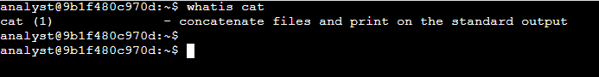
- What are the first two words of the short description of cat returned by whatis?
  - Answer: The first two words of the short description returned are “concatenate files.”

Get detailed information about cat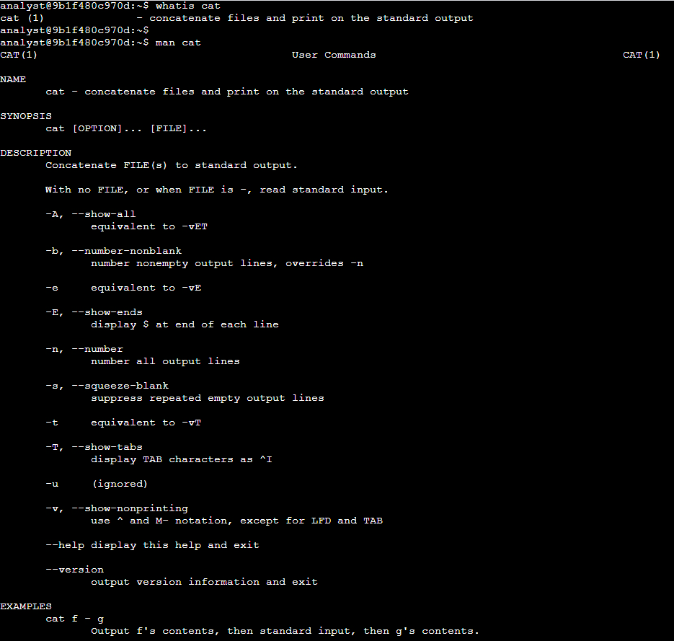
- What option can you use to number the output lines of the cat command?
  - Answer: The -n,--number option numbers all the output lines.

Find the command that prints the first part of a file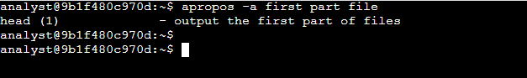
- Which command returns the first part of a file?
  - Answer: The head command returns only the first part of a file.

Task 2: Explore the useradd command
Open manual for useradd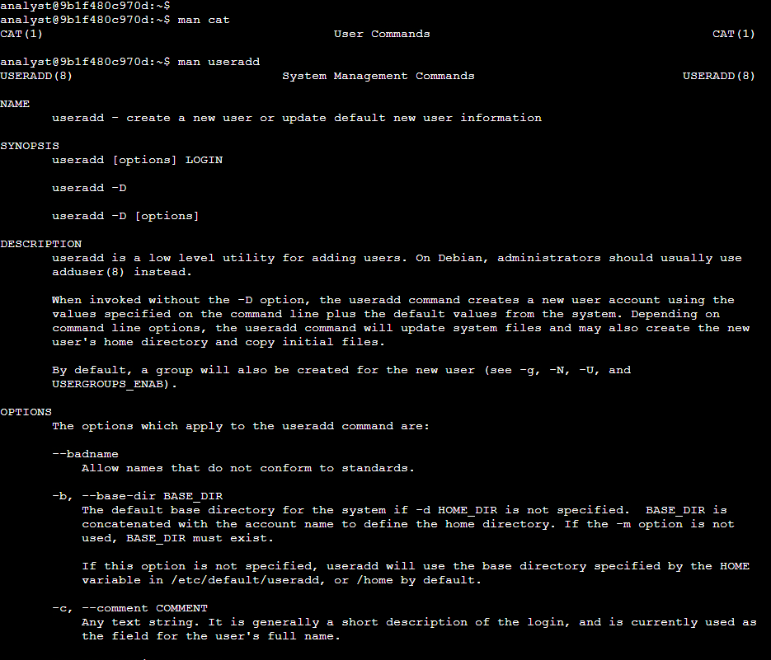
- Which option can be used with the useradd command to set an expiration date for a temporary user account?
  - Answer: The -e option can be used to set an expiration date for a temporary user account.

Task 3: Explore the rm and rmdir commands
Get a short description of rm and rmdir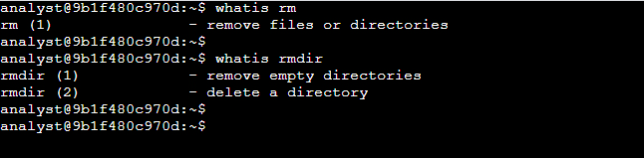
- Which of these commands removes only empty directories?
  - Answer: The rmdir command removes only empty directories.

Task 4: Determine which command to use
Search for the command to create a new group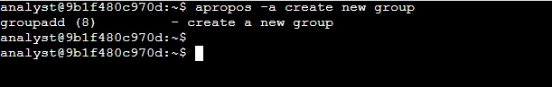

- What command can you use to create a new group?
  - Answer: The groupadd can be used to create a new group.

Tasks Completed
- Get short command descriptions – Used whatis cat to learn that the cat command is used to concatenate files, and whatis rm / whatis rmdir to determine that rmdir removes only empty directories.
- Read detailed manual pages – Used man cat to find the -n option for numbering lines, and man useradd to learn that the -e option sets an expiration date for a user account.
- Search for commands by keywords – Used apropos -a first part file to identify the head command, which returns the first part of a file, and apropos -a create new group to find the groupadd command.
- Compare similar commands – Determined the functional difference between rm (removes files and directories) and rmdir (removes only empty directories).

Skills Demonstrated
- Retrieving concise command descriptions with whatis
- Reading and navigating Linux manual pages with man
- Searching the manual page database with apropos
- Identifying correct command options for specific tasks
- Distinguishing between similar Linux commands

Glossary
whatis cat
- whatis—Displays a short, one-line description of a command from the manual page database.
- cat—The command to get information about; used to concatenate and display file contents.
man cat
- man—Displays the manual (man) page for a command, including syntax, description, and available options.
- cat—The command to display the manual for.
apropos -a first part file
- apropos – Searches the man page database for commands related to a keyword.
- -a – Requires that all specified keywords match.
- first part file—the keywords to search for.
man useradd
- useradd—Command to create a new user account.
- Viewed in man to find options like -e for setting an account expiration date.
whatis rm
- Displays a brief description of the rm command, which removes files or directories.
whatis rmdir
- Displays a brief description of the rmdir command, which removes only empty directories.
apropos -a create new group
- Searches the man page database for commands matching create, new, and group.
- Identifies groupadd as the command to create a new group.

